Kumar website review and correction

- Website - Kumarworld.com

- Main Website - correction

Banner Adaptation:
URL - https://www.kumarworld.com/
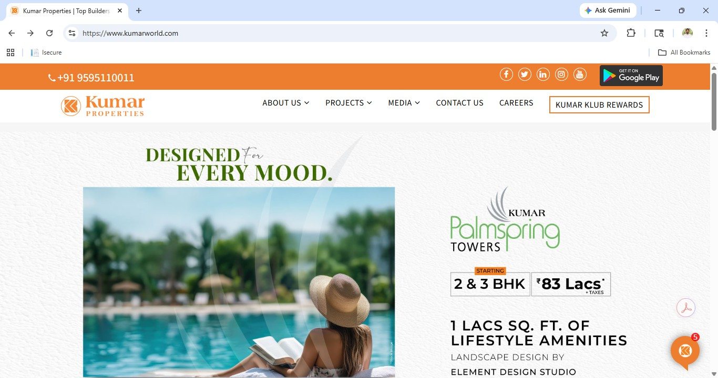
Issue - Website banners should be optimized for Bangalore speciﬁc projects and campaign creatives, ensuring seamless adaptation across both mobile and desktop versions.

Drive Links:
Plumeria Elevation Image – Remove Marketing Partner, Phone Number Should be changes -https://drive.google.com/drive/folders/1S_0fG56ogJ66LHxlga1HtPHbHDc5J1M8?usp=sharing
Prospera - https://drive.google.com/file/d/1XRZJrtFJTzxkvyr7CTfm59ESWXoj4Yks/view?usp=drive_link
Platina – Will be provided shortly.
Palazzio - Will be provided shortly.

Contact details:
URL: https://www.kumarworld.com/
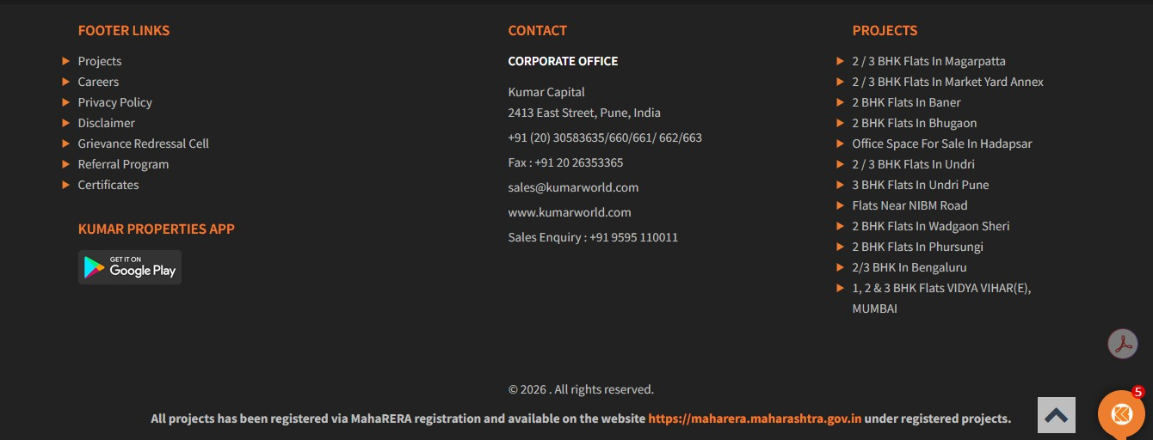
Issues: Contact details should be speciﬁc to Bangalore, including the relevant contact number, email ID.

Contact Number: +91 80-412-80992
Email Id: bangalore@kumarworld.com
Address: No. 23/3, Crescent Road, High Grounds, Opp. Taj West End Hotel – Back Gate, Bengaluru - 560001

Segregation:
URL: https://www.kumarworld.com/residential-in-bengaluru/ Issue: Projects should be categorized into four segments: Ongoing, Upcoming, Launch, and Completed.
      - Ongoing: Kumar Plumeria, Kumar Prospera,
      - Completed: Kumar Princetown, Kumar Princetown Royal, Kumar Prince Ville, Kumar Kino Platinum.
      - Launch: Kumar Platina, Kumar Palazzio.
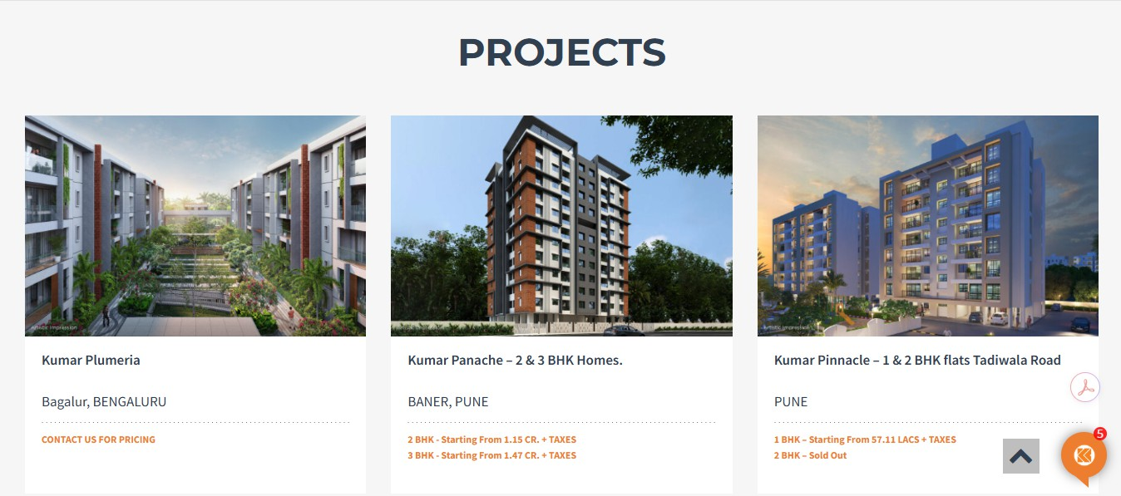
      - Upcoming: New Nandi Hills.
      - Drive Link: https://drive.google.com/drive/folders/1zCNOzaGEW_B_hpIBJIKsaJ2P9gjIM9Tz?usp=sharing

Chatbot:
Issue: The website chatbot/live chat isn’t showing Bengaluru projects in its responses or listings, which suggests that it isn’t properly synced with the Bangalore-speciﬁc inventory.
Project Details Word Document: https://drive.google.com/drive/folders/1GiJr6bK6iRUsyD-2dz_Jier7VRXV8Ctl?usp=sharing

Main Website Individual Project Correction:
  - Kumar Plumeria:
URL: https://www.kumarworld.com/properties/kumar-plumeria/

Feature Projects:
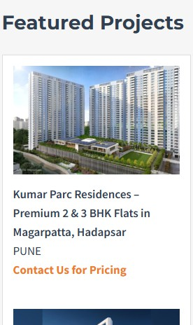
Issue: In the Featured Projects section, only Bengaluru projects should be displayed, either through geo-targeting or by fully adapting the visuals and creatives.
Drive Link: https://drive.google.com/drive/folders/1zCNOzaGEW_B_hpIBJIKsaJ2P9gjIM9Tz?usp=sharing

Slider:
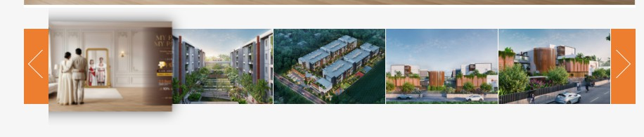
Issues: The image slider is not functioning properly. Images should transition automatically and also allow manual navigation through the slider controls.
Drive Links: https://drive.google.com/drive/folders/1Oukpiy3iXDMHgbU9ljl5uphTfFR6Yg5-?usp=drive_link

Spelling Correction:
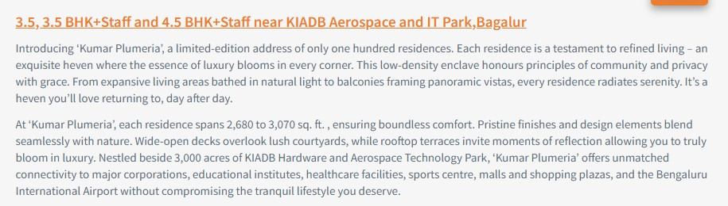
Issue: Spelling corrections are required. ‘Heven’ should be updated to ‘Heaven’. Please review and verify all content for any additional spelling errors.

Exclusive Advantage:
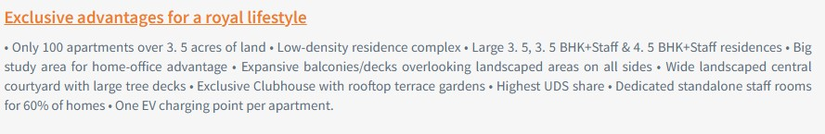
Issue: “Exclusive Advantage” should be presented as bullet points instead of a paragraph, consistently across both mobile and desktop version.

Layout Plan:
Issue: The layout plan should be enhanced to appear larger with clear and readable text across both mobile and desktop versions.
Drive Link: https://drive.google.com/drive/folders/1hjzAH1RjVTMk3acL34sZfGogBNYCbdCX?usp=drive_link
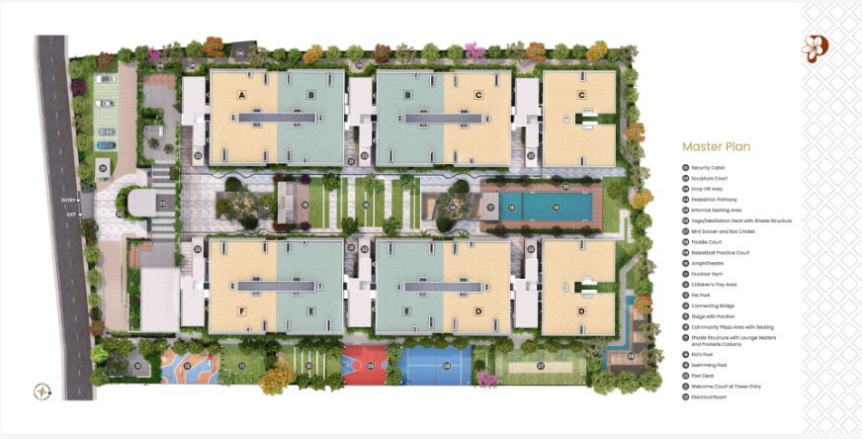

Walkthrough, 360° View:
Issue: Key content assets - virtual walkthroughs, 360° interactive tours, event coverage, PR articles, and awards imagery are either missing or not integrated into the website.
Walkthrough, 360°:
Plumeria: https://kumarplumeria.com/index.php (Refer to Website for 360°), https://drive.google.com/drive/folders/14A_KWwBmg-C9sIMrwccnaDjxa4g5LJ5l?usp=sharing (Drive Link)
Prospera: Walkthrough Video - https://youtu.be/8AaVQ6JFnbo?si=7IFSTD-YL80GQ_EJ (Refer to YouTube Video)
Events, PR & Awards: Will be provided shortly.

Construction Status:
Issues: Construction status should be included for all projects, with monthly updates, as this information is currently missing.
Drive Link:
Prospera: https://drive.google.com/drive/folders/1y3rZHoxFhX4lpfFPUUH4d-r7FCAmm4SU?usp=sharing
Plumeria: https://drive.google.com/drive/folders/1KvQBYXasi0ivVP3FfuRFTq8VwwXj8oRZ?usp=sharing
Platina: (Excavation & Piling work)
https://drive.google.com/drive/folders/1pcMo6vRl9mfDZmBFv5AHj7dPypOmZRlh?usp=sharing

Kumar Prospera:
URL: https://kumar-prospera.in/

Banner Adaptation:
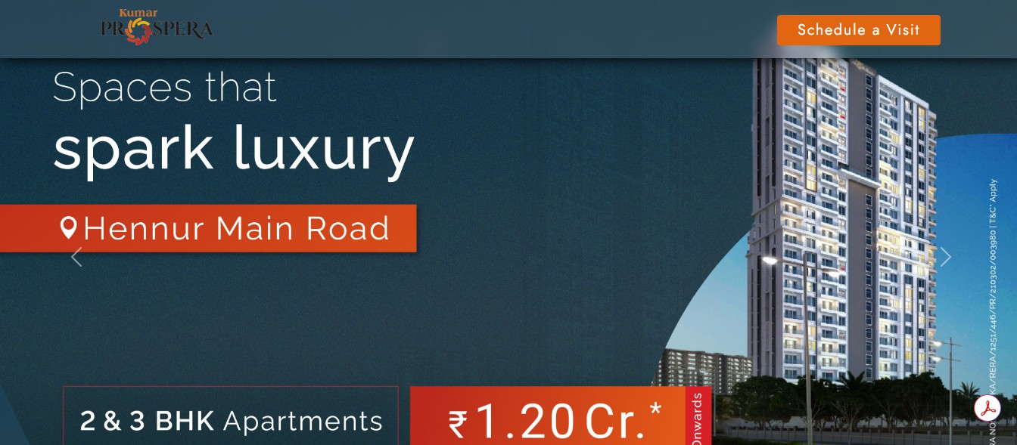
Issue: New banner images should be implemented with 4–5 visuals, featuring both auto-slide and manual navigation options, optimized for mobile and desktop versions.

Drive Link: https://drive.google.com/drive/folders/1VGA0xXr1oSrjrtjCTGZoWsCDBd-aqUfN?usp=sharing
    - Website: https://kumarcorp.kumarworld.com/

  - Main Website: Correction

All Projects:
URL: https://kumarcorp.kumarworld.com/projects
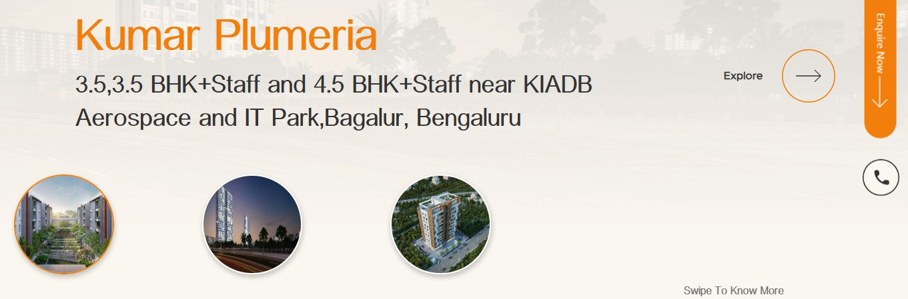
Issues: Only 2 projects are currently visible on the website under the Projects section. All active, completed, and upcoming projects need to be listed.

    - Visual Representation:
URL: https://kumarcorp.kumarworld.com/projects
Issue: Project images should be displayed in a rectangular format for better visibility and a more customer-friendly viewing experience, instead of the current circular format.

Contact details:
URL: https://kumarcorp.kumarworld.com/projects
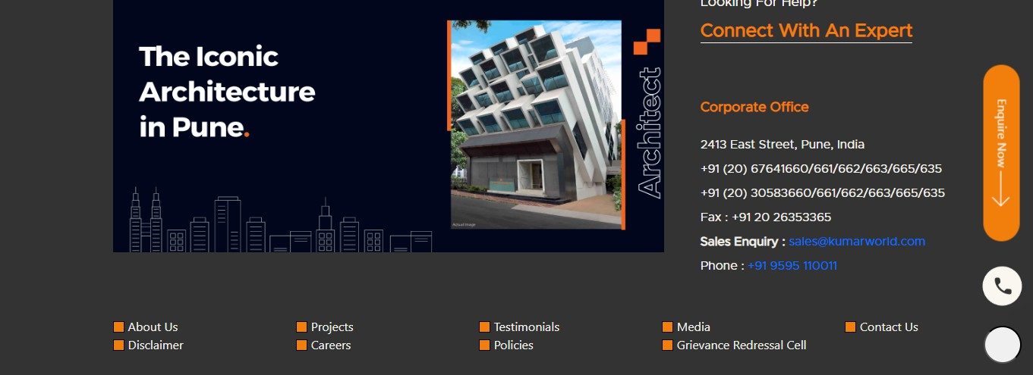
Issue: Website banners should be optimized for Bangalore speciﬁc projects and campaign creatives, ensuring seamless adaptation across both mobile and desktop versions.

Contact Number: +91 80-412-80992
Email Id: bangalore@kumarworld.com
Address: No. 23/3, Crescent Road, High Grounds, Opp. Taj West End Hotel – Back Gate, Bengaluru - 560001

Main Website Individual Project Correction:

    - Kumar Plumeria:
URL: https://kumarcorp.kumarworld.com/project/plumeria

Amenities Images:
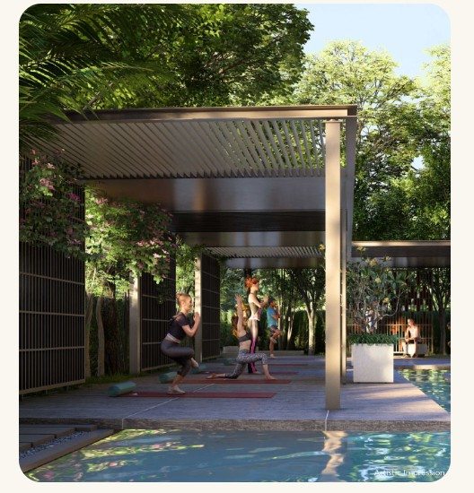
Issues: Only one amenity is currently displayed, please add 4–5 amenity images in the image section near the amenities section.
Drive Link: https://drive.google.com/drive/folders/12AMiRQJG41D9QYZwxdthlXs5sjB7NDw-?usp=sharing

Spelling Correction:
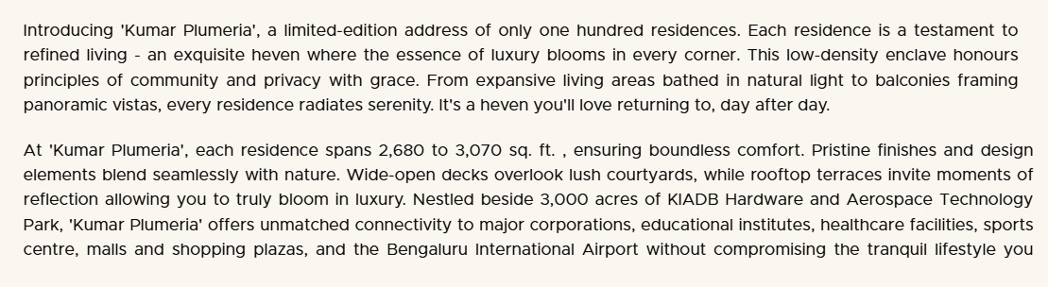
Issue: Spelling corrections are required. ‘Heven’ should be updated to ‘Heaven’. Please review and verify all content for any additional spelling errors.

Exclusive Advantage:
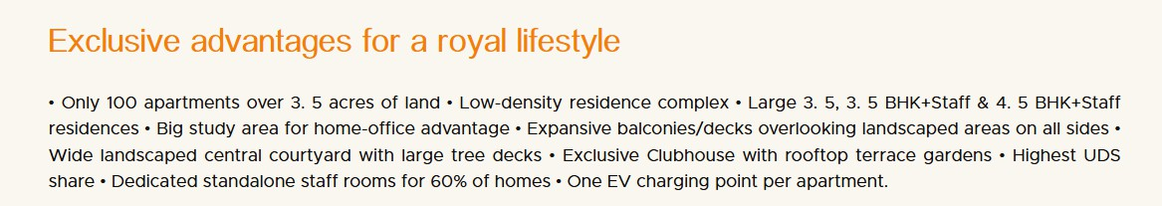
Issue: “Exclusive Advantage” should be presented as bullet points instead of a paragraph, consistently across both mobile and desktop versions.

Corrected Format:
• Only 100 apartments over 3. 5 acres of land.
• Low-density residence complex.
• Large 3.5 BHK, 3.5 BHK+Staff & 4.5 BHK+Staff residences.
• Big study area for home-office advantage.
• Expansive balconies/decks overlooking landscaped areas on all sides.
• Wide landscaped central courtyard with large tree decks.
• Exclusive Clubhouse with rooftop terrace gardens.
• Highest UDS share.
• Dedicated standalone staff rooms for 60% of homes.
• One EV charging point per apartment.

Kumar Prospera:
URL: https://kumarcorp.kumarworld.com/project/kumar-prospera-Bengaluru

A. Enquire Now:
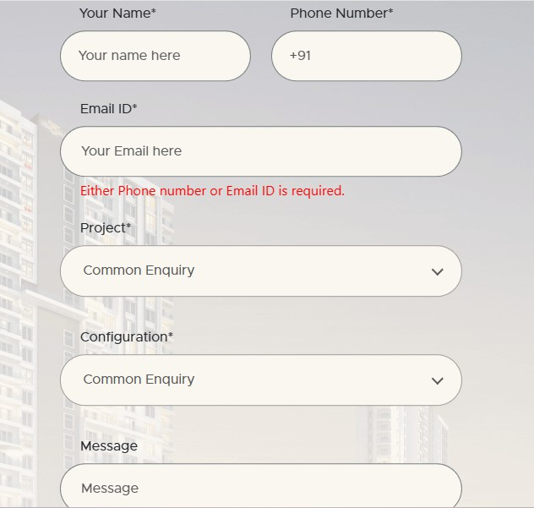
Issue: In the Enquire Now form, Kumar Prospera is not getting auto-ﬁlled.

